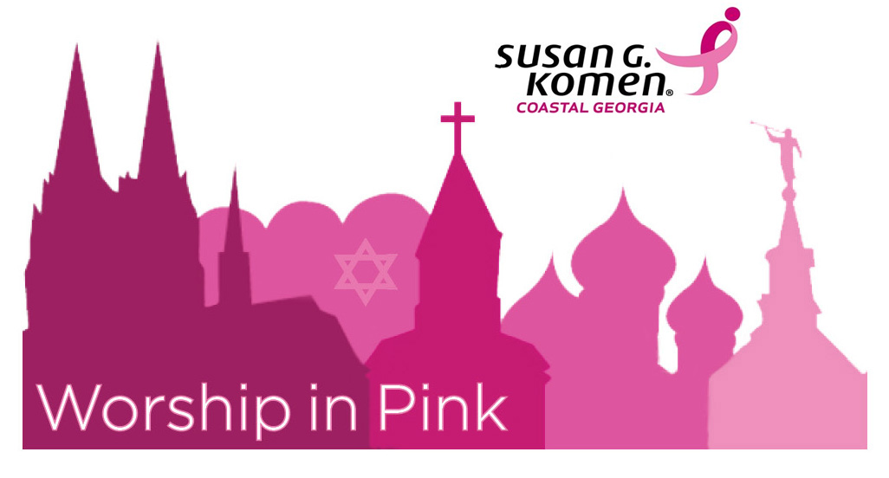
Susan G. Komen Coastal Georgia
Worship in Pink Tool Kit

This toolkit is designed to provide faith-based organizations with ideas and resources to help plan, develop, and implement Worship In Pink events.
The resources in the toolkit are free, simple, and easy to use!

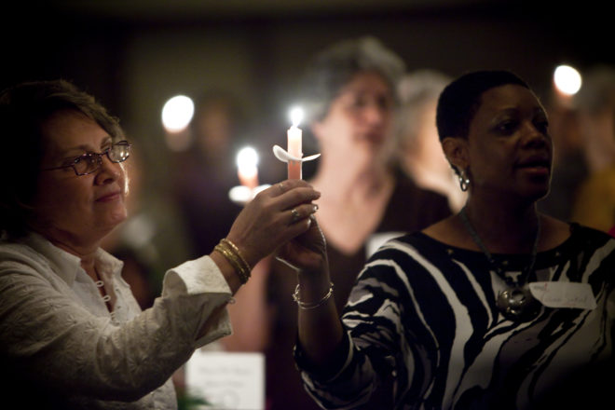

Event Ideas

- Invite breast cancer survivors to speak to the congregation

- Invite a health care professional to speak to the congregation about the importance of mammograms and early detection

- Have a message from the preacher about the importance of breast health Invite a speaker to attend Bible study or Sunday school and share their story

- Have a moment of silence or prayer in honor of those who have been affected by breast cancer

- Recognize survivors and/or co-survivors during the service/ceremony

- Run script including names of survivors on screen

- Host a candlelight vigil for breast cancer survivors and co-survivors

- Serve pink lemonade and pink cake at a reception before or after services

- Hand out pink flowers in honor of survivors and white flowers in memory of those who have died

- Have members wear pink ribbons or an article of pink clothing

- Host a women’s only educational event on Friday evening

- Set up an education booth

- Create a pink bulletin board with breast health information and/or survivor photos

- Encourage women to take the commitment challenge

- Include breast cancer awareness facts in the bulletin or announce throughout the service

- Collect a special donation from members of the congregation to be made to Susan G. Komen Coastal Georgia

Suggested Script for the Worship service

Nancy G. Brinker promised her dying sister, Susan G. Komen, she would do everything in her power to end breast cancer forever. In 1982, that promise became Susan G. Komen for the Cure® and launched the global breast cancer movement. Today, Susan G. Komen is the boldest community fueling the best science and making the biggest impact in the fight against breast cancer. Thanks to events like the Komen Race for the Cure, we have invested almost $3 billion to fulfill our promise, working to end breast cancer in the U.S. and throughout the world through ground-breaking research, community health outreach, advocacy and programs in more than 60 countries.

In keeping with the mission of Susan G. Komen, the Komen Coastal Georgia Affiliate is offering the “Worship in Pink” program to raise breast cancer awareness by distributing breast cancer educational materials through churches, synagogues, mosques and other places of worship in Coastal Georgia. Today, we as a faith community have partnered with Komen Coastal Georgia to open the lines of communication about breast health, promote breast cancer education and celebrate the lives of those who have fought against breast cancer. After today’s service, we will be handing out breast cancer educational materials and information about local resources. Once you have read this material, please pass along these life-saving messages to a friend or family member. Together we can end breast cancer forever. Thank you for participating. If you are interested in learning more about Komen Coastal Georgia, please access their website at www.komencoastalgeorgia.org or call 912-232-2535.

Sample Bulletin Announcements

Join us for Worship in Pink, [DATE.]

“Join your fellow members in celebrating Worship In Pink on [DATE,] to raise awareness about breast cancer. Participants will receive free breast health education materials which discuss risk factors and the critical role of early detection in saving lives, as well as resources for free and reduced cost screening locations. We ask that you wear something pink or (INSERT OTHER PROGRAM IDEA HERE) to show your support. Join us as we honor survivors for their courage and pray for those who have lost their lives to breast cancer. Share with your friends, family members, and neighbors the life-saving message of early detection!”

OR

“Our congregation has designated today as “Worship in Pink” day to increase breast cancer awareness by distributing educational material throughout our community. As a faith-based community, we have partnered with Susan G. Komen Coastal Georgia (& insert any other partners you are working with) to open the lines of communication about breast health, promote breast cancer education and celebrate the lives of those who have fought breast cancer. In 2018, it is estimated that 266,120 women and 2,550 men will be diagnosed with breast cancer nationwide. We want to share the message that early detection saves lives. While the 5-year survival rate for late stage, distantly spread breast cancer is only 27%, early stage breast cancer (when treated) has a 98% 5-year survival rate.”

Sample Unified Prayer - created by Rabbi Kathy Cohen

We pray to you for strength, healing and a cure. Breast cancer has ravaged so many of our women. Hear our prayer and ease our anxieties.

We pray for those who devote themselves to research for a cure. Give them insight and wisdom. Let their labor be productive and rewarding.

We pray for those who are stricken with breast cancer. Give them strength and complete healing. Let us provide them with comfort and caring.

We pray for those who have survived breast cancer. Give them confidence and faith. Let them continually experience the gift of renewed health.

We pray for those who will one day fall ill with breast cancer. Give them new treatments and protect them from pain. Let them not experience fear and doubt.

We pray to You for strength, healing and a cure.

Step-by-Step Guide to Planning your Event:

- Setting up Your Committee and Pre-Planning
  - Determine who will serve as the co-chairs
  - Determine who will be on the committee
  - Set meeting dates and times for planning

- Start Planning with Your Committee
  - Meet with your committee to decide:
    - What type of event do you want?
    - What time and day?
    - What kind of decorations will in require?
    - Do you want to provide food? If so, what kind and how much will it cost?
    - Do you want speakers for your event? Consider asking a breast cancer survivor to speak
      - If you do not have a survivor but would like to have one speak at your event, contact Komen Coastal Georgia at 912-232-2535.
    - Will you give out goodie bags or roses?
    - Who will be responsible for set up?
    - Who will be responsible for clean up?
    - How many volunteers will you need?
  - Delegate tasks
  - Set a timeline and due date for tasks

- Promoting Your Event
  - Flyers or posters
  - Church newsletter or bulletin
  - Email and social media
  - Press release

- Implementing Your Event
  - Be sure volunteers know their assignments
  - Ensure that you have all materials to give out to participants
  - Make sure speaker(s) have been approved and are prepared for your event
  - Confirm outside partners and their role during your event
  - Contact media or designate individuals to take photos to document your event/activities

- Following-Up
  - Conducting follow-up is important to assist in evaluating your success and planning for future events
    - Determine how the audience felt about the event, how smoothly planning went, and what were the most effective activities and materials
  - Evaluating your event:
    - Count the number of individuals attending the event
    - Document the number and titles of materials distributed
    - Collect contact information of your partners and speakers
    - Hold a post event meeting with your leadership and volunteers
    - Send event recap and pictures to Komen Coastal Georgia

Breast Cancer Facts
- Except for skin cancers, breast cancer is the most common cancer among women.

- Rates of breast cancer vary among different groups of people. Rates vary between women and men and among people of different ethnicities and ages. They vary around the world and across the U.S.

- The most common risk factors for getting breast cancer are being female and growing older.

- One woman is diagnosed with breast cancer every two minutes, and one woman will die of breast cancer every 13 minutes in the U.S.

- Women who don’t have health insurance are much less likely to get mammograms than women with health insurance.

- Among women in the U.S., rates of breast cancer incidence (new cases) and mortality (death) vary by race and ethnicity.

  - White and black women have the highest breast cancer incidence overall. American Indian/Alaska Native women have the lowest.

- In 2018, it is estimated that among U.S. women there will be:
  - 266,120 new cases of invasive breast cancer
  - 40,920 breast cancer deaths
- About five to ten percent of breast cancers in the U.S. are due to inherited genetic mutations.

- Most women who are diagnosed with breast cancer in the U.S. have no family history of the disease.

- There are more than 3.5 million breast cancer survivors in the U.S. today.

- Breast cancer survival depends on a person’s diagnosis and treatment. A main factor in survival is breast cancer stage at diagnosis and prompt, effective treatment.
- Breast cancer is the most common cancer among African-American women, but the second leading cause of cancer death (lung cancer is number 1).
- To date, Komen has provided more than $956M to researchers in 47 states, the District of Columbia and 21 countries to support research that has resulted in a better understanding of breast cancer; earlier detection; personalized, less invasive treatments for what was once a “one-treatment-fits-all” disease; and improvements in both quality of life and survival rates.

For more breast cancer facts and figures, visit www.komen.org

Komen Coastal Georgia Statistics

- 1 in 4 women in Coastal Georgia have no health insurance

- Nearly 40% of women over age 40 did not receive a mammogram in the last 12 months

- Obstacles to screening include financial barriers, fears, and misperceptions.

- The Komen Coastal Georgia Affiliate has a substantially larger percentage of people in medically underserved areas than Georgia and the U.S.

Komen’s Four Key Messages for Breast Self-Awareness:

- Know your risk
- Talk to your family to learn about your family health history
- Talk to your doctor about your personal risk of breast cancer

- Get screened
- Ask your doctor which screening tests are right for you if you are at a higher risk
- Have a mammogram every year starting at age 40 if you are at average risk
- Have a clinical breast exam at least every 3 years starting at 20, and every year starting at 40.

- Know what is normal for you
- See your health care provider right away if you notice any of these breast changes:
  - Lump, hard knot or thickening inside the breast or underarm area
  - Swelling, warmth, redness or darkening of the breast
  - Change in the size or shape of the breast
  - Dimpling or puckering of the skin
  - Itchy, scaly sore or rash on the nipple
  - Pulling in of your nipple or other parts of the breast
  - Nipple discharge that starts suddenly
  - New pain in one spot that doesn’t go away

- Make healthy lifestyle choices
- Maintain a healthy weight
  - Being overweight after menopause increases the risk of breast cancer.
  - Weight gain of 20 pounds or more after the age of 18 may increase your risk of breast cancer.
  - If you have gained weight, losing weight may lower your risk of breast cancer.

- Add exercise into your routine
  - Physical activity not only burns energy (calories) but may help lower your risk of breast cancer. (This benefit is seen most clearly in women after menopause.) Exercise fights obesity and may lower estrogen levels. It may also boost the immune system so that it can help kill or slow the growth of cancer cells. Here is all it takes to get started:
  - Include physical activity in your daily routine. All you need is moderate (where you break a sweat) activity — like brisk walking for 30 minutes a day.
  - Do whatever physical activity you enjoy most and gets you moving.
  - After exercising, think about how good you feel. Use that feeling to motivate you the next time.
  - If you are already physically active, keep up the good work.

Before you start an exercise program, see a doctor if you:
• Have been inactive for a long time
• Are overweight
• Have a high risk of heart disease
• Have a high risk of or have other chronic health problems

- Limit alcohol intake
  - You may have heard about research that showed having a glass of red wine each day reduces your risk of heart disease.
  - Many studies have also shown that drinking alcohol increases the risk of breast cancer.
  - The more alcohol you drink, the higher your risk of breast cancer.
  - If you drink alcohol, have less than one drink a day.

- Limit postmenopausal hormone use
  - For each year that combined estrogen plus progestin hormones are taken, the risk of breast cancer goes up. Once they are stopped, in about 5 to 10 years, this increased risk returns to that of a woman who has never used hormones.
  - Menopausal hormones also increase the risk of ovarian cancer and other health problems.
  - Talk to a doctor about the risks and benefits.

- Breastfeed if you can
  - Breastfeeding protects against breast cancer, especially in premenopausal women.

WHERE TO FIND HELP and RESOURCES

- Komen Coastal Georgia provides community health grants to service providers that provide free breast cancer screening and diagnostic testing for individuals who qualify.
  - Call us at 912-232-2535 to find a service provider near you.
  - Go online to www.komencoastalgeorgia.org
- The Breast and Cervical Cancer Program (BCCP) provides free breast and cervical cancer screening to eligible women between the ages of 40-64. Call your local county health department to find out more, or visit: https://dph.georgia.gov/BCCP
- Need help or more information? Call 1-877-GO-KOMEN

For more information about breast health or breast cancer, please visit: www.komen.org or
http://komencoastalgeorgia.org/get-involved/worship-in-pink/ to download reproducible, free breast health resources in PDF format.

Additional information about Susan G. Komen Coastal Georgia and Georgia breast cancer statistics can be found in the 2015 Komen Community Profile available online:
https://komencoastalgeorgia.org/wp-content/uploads/2013/10/Komen_Coastal_Georgia_2015_Community_Profile_Report.pdf

Our Bold Goal: to reduce the current number of breast cancer deaths by 50% in the US by 2026.

For more information about Komen Coastal Georgia or Worship In Pink, please contact:

Susan G. Komen Coastal Georgia
7505 Waters Ave., Unit A10
Savannah, GA 31406
Phone: 912.232.2535
Fax: 912.544.0323
Website: www.komencoastalgeorgia.org
Email: julie@komencoastalgeorgia.org

